Lab Task-1

Instructions: Please read carefully
- Please rename this file as only your ID number (e.g. 18-*****-1.doc or 18-*****-1.pdf).
- Submit the file before the deadline in VUES under Lab Task-1. If you cannot complete the full task, do not worry. Just upload what you have completed.
- Initialize an array of 10 elements and print the array elements both in normal and reverse order.
For example,
Input: 12 32 43 1 54 53 15 64 3 13
Output: 13 3 64 15 53 54 1 43 32 12
Your code here:
#include<iostream>
#include<string.h>

using namespace std;
int main(void)
{
int n=10;
int i;

int a[n];
cout<<"Take 10 number of inputs respectively : "<<endl;
for(i = 0; i < n; i++)
{
cin>>a[i];
}
cout<<"Current order : ";
for(i = 0; i < n; i++)
cout<< a[i]<<" ";
cout<<endl;
cout<<"Reverse order : ";
for(i = n-1; i >= 0; i--)

cout<<a[i]<<" ";
return 0;
}

Your whole Screenshot here: (Console Output):

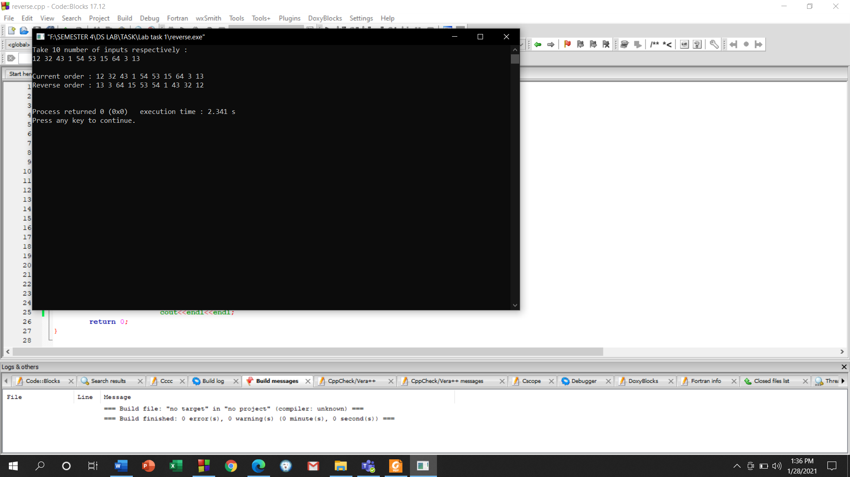

- Initialize an integer array of 10 elements and print how many numbers are odd and how many numbers are even.
For example,
Input: 12 32 43 1 54 53 15 64 3 13
Output:
6 odd numbers
4 even numbers
Your code here:
#include<iostream>
#include<string.h>
using namespace std;
#define num_size 10
int main()
{
int num[num_size];
int even,odd,i;
even=odd=i=0;
cout<<"Enter 10 Number Respectively:"<<endl;
for(i=0;i<10;i++)
{

cin>>num[i];

if (num[i]%2==0)
{
even++;
}

else
{
odd++;
}

}
cout<<odd<<" Odd numbers"<<endl;
cout<<even<<" Even numbers"<<endl;

}

Your whole Screenshot here: (Console Output):

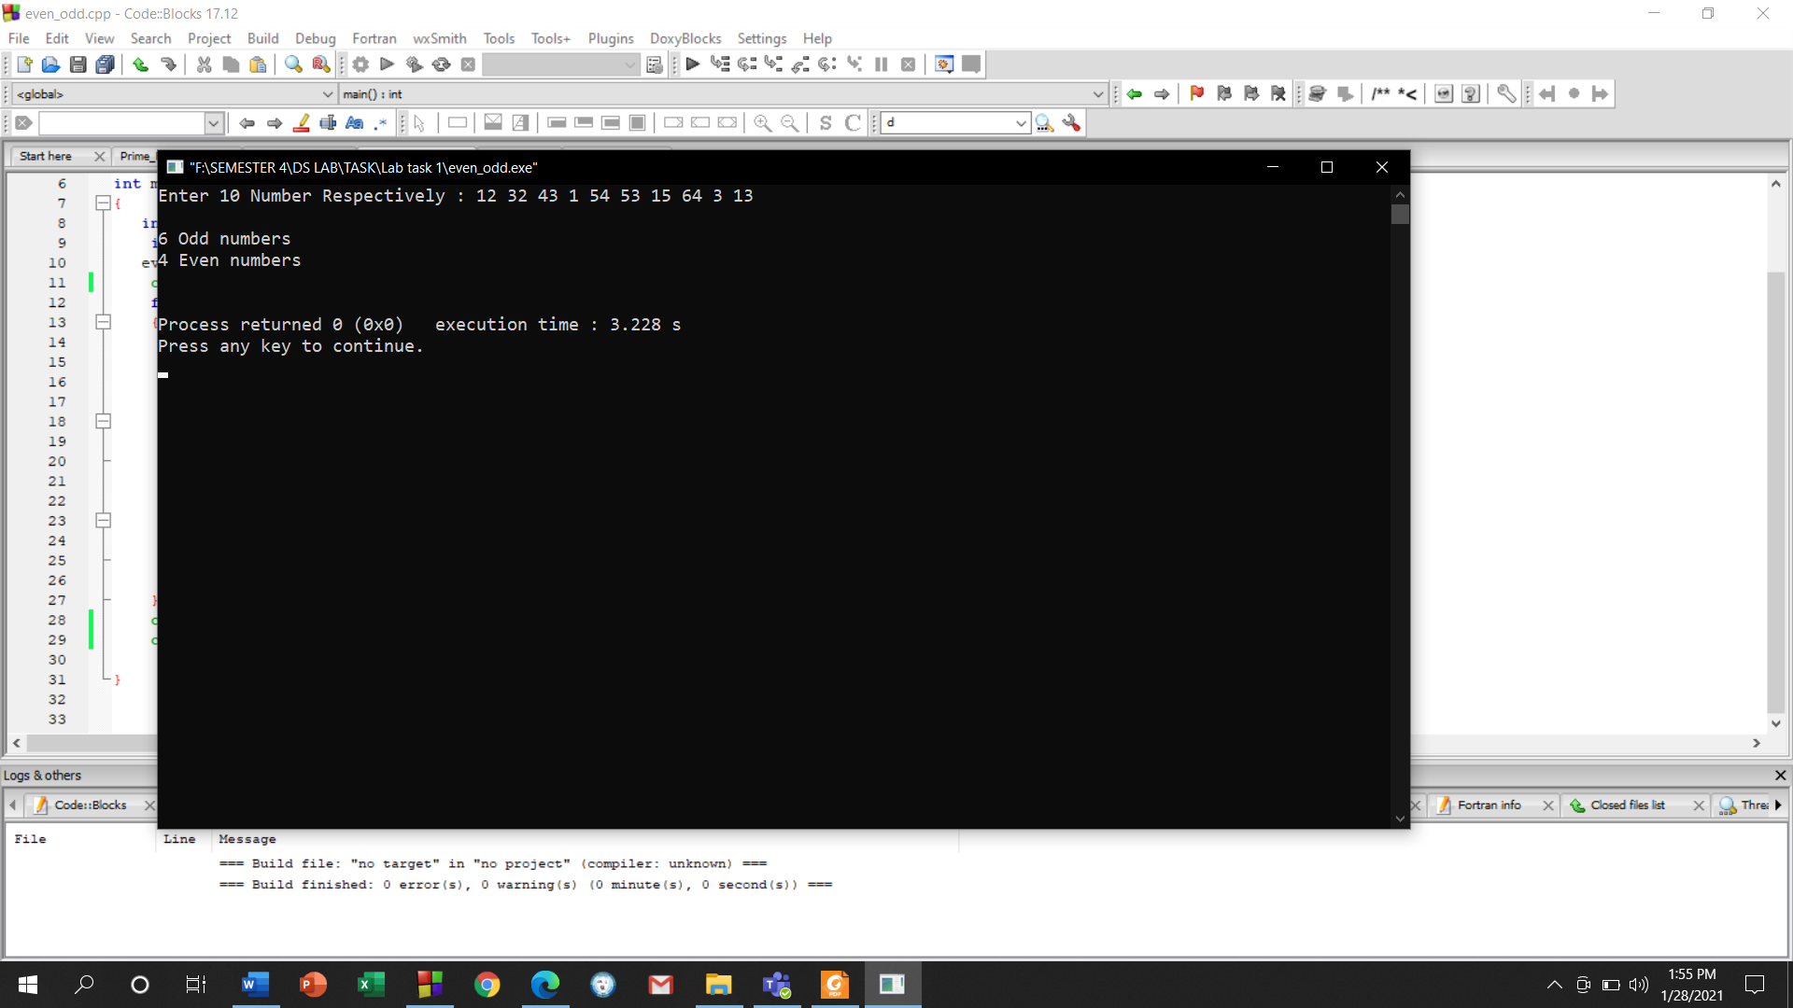

- Write a function that takes TWO parameters to print all the odd numbers between a given range. Input the starting value of the range and ending value of the range. Then, send them as the parameters to your function.
For example,
Output:
Starting value: 12
Ending value: 23
13 15 17 19 21 23
Your code here:
#include<iostream>
#include<string.h>
using namespace std;
int func(int a,int b)
{

for (int i=a; i<=b; i++)
{
if (i%2!=0)
{
cout<<i<<" ";
}
else{}
}

}
int main()
{
int a,b;
cout<<"Starting Value : ";
cin>>a;
cout<<"Ending Value : ";
cin>>b;
func(a,b);
}

Your whole Screenshot here: (Console Output):

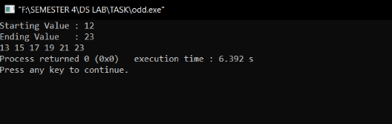

- Write a program to perform matrix addition between 3 matrices.
For example,
Input:
12 13 14 1 2 3 101 104 107
15 16 17 4 5 6 102 105 108
18 19 20 7 8 9 103 106 109
Output:
114 119 124
121 126 131
128 133 138

Your code here:
#include <iostream>
using namespace std;

int main()
{
int r, d, a[10][10], b[10][10],c[10][10], sum[10][10], i, j;

cout << "Enter number of rows : ";
cin >> r;

cout << "Enter number of columns : ";
cin >> d;

cout << endl << "Enter elements of 1st matrix: " << endl;
for(i = 0; i < r; ++i)
for(j = 0; j < d; ++j)
{
cin >> a[i][j];
}

cout << endl << "Enter elements of 2nd matrix: " << endl;
for(i = 0; i < r; ++i)
for(j = 0; j < d; ++j)
{
cin >> b[i][j];
}

cout << endl << "Enter elements of 3rd matrix: " << endl;
for(i = 0; i < r; ++i)
for(j = 0; j < d; ++j)
{
cin >> c[i][j];

}

for(i = 0; i < r; ++i)
for(j = 0; j < d; ++j)
sum[i][j] = a[i][j] + b[i][j]+ c[i][j];

cout << endl << "Addition of 3 matrices is: " << endl;
for(i = 0; i < r; ++i)
for(j = 0; j < d; ++j)
{
cout << sum[i][j] << " ";
if(j == d - 1)
cout << endl;
}

return 0;
}

Your whole Screenshot here: (Console Output):

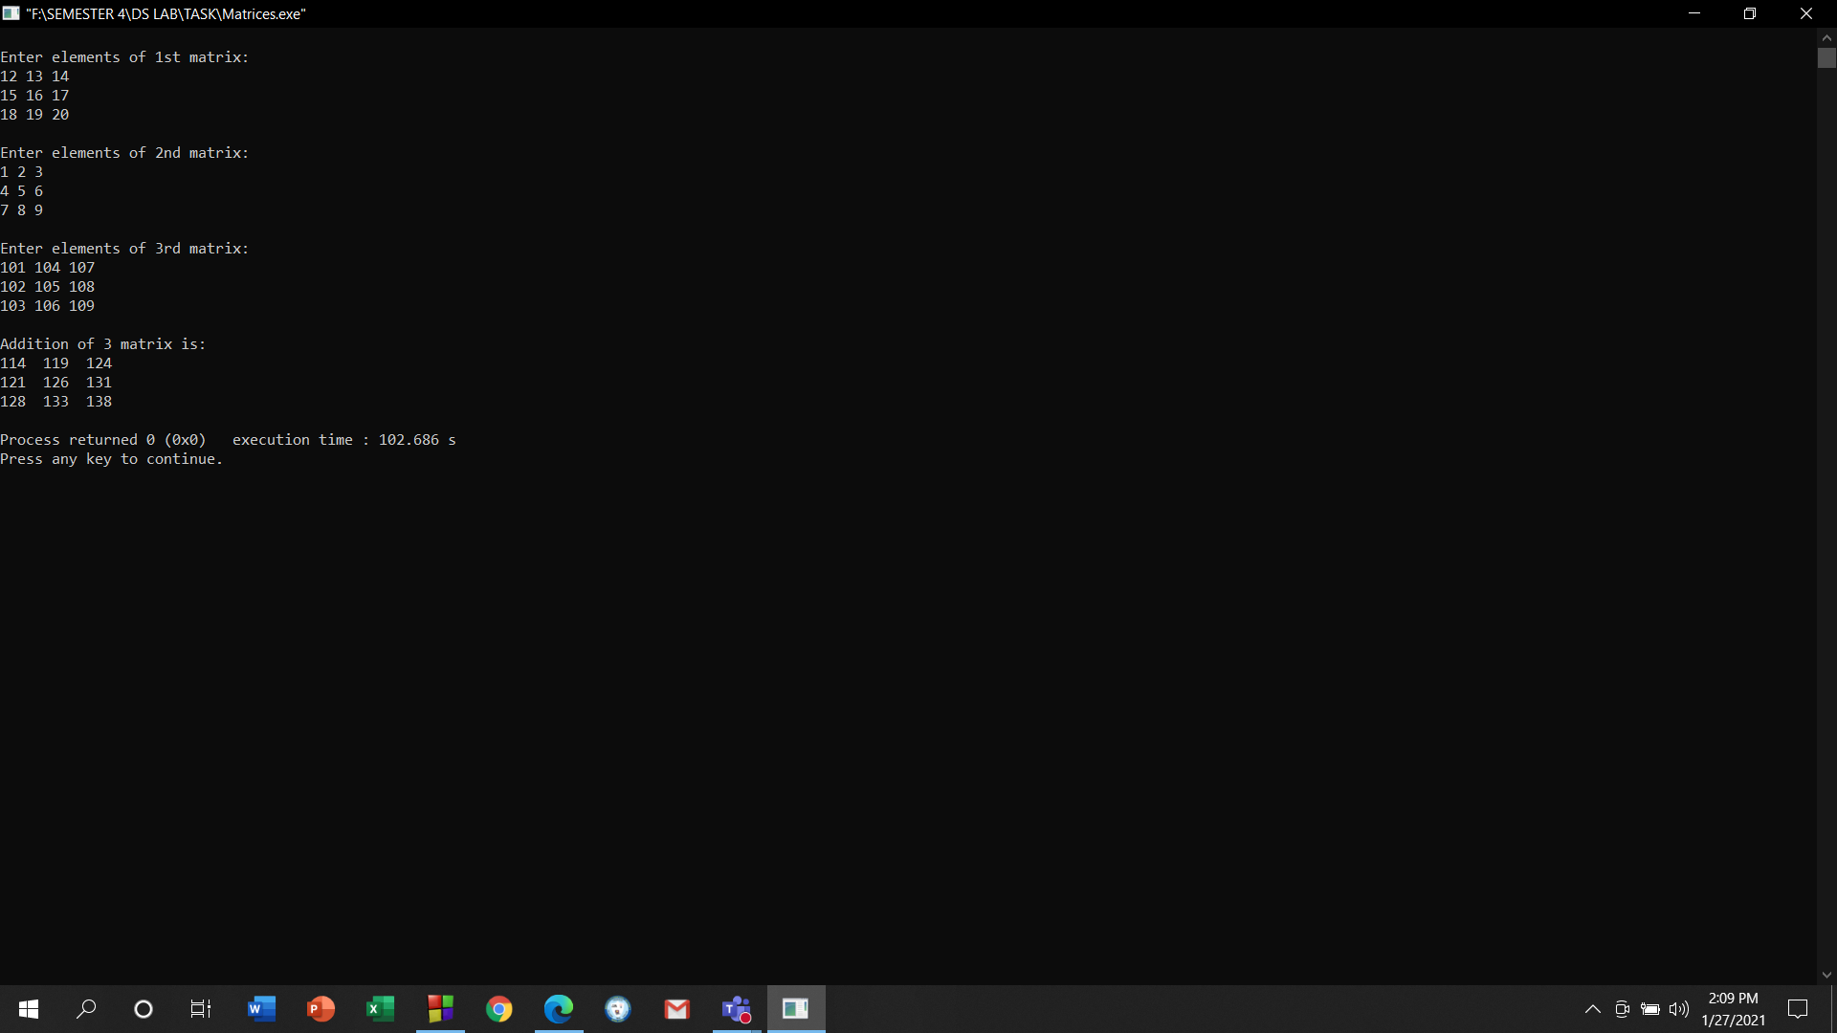

- Write a function to calculate factorial of a given integer number if that number is a prime number. If it is not, it will give an error.
For example,
Scenario 1
Input: 5
Output: 120
Scenario 2
Input: 4
Output: Error! Not a prime number.
Your code here:
#include<iostream>
#include<string.h>
using namespace std;
int Prime(int n)
{
int i, c=0;
for(i=2; i<=n/2; ++i)
{
if(n%i==0)
{
c++;
}
}
if (c==0)
{
int f=1;
for (int i=1;i<=n;i++)
{
f=i*f;
}
cout<<f;

}
else
{
cout<<"ERROR! Not a prime number"<<endl;
}
}
int main()
{
int n;
cout<<"Enter A Number to check:";
cin>>n;
Prime(n);
return 0;
}

Your whole Screenshot here: (Console Output):

Scenario 1

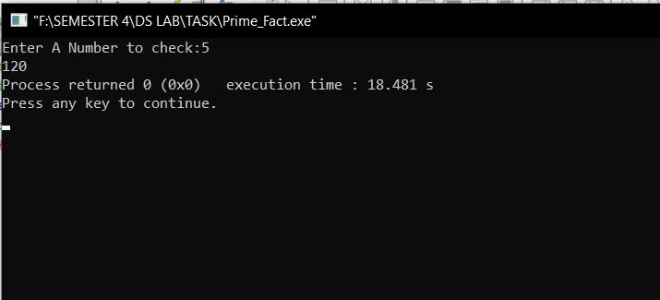
Scenario 2

